<Booking Module> by <Oh Jia Quan>

4.1.1 Brief Description

There are 4 main function in this module which is Add Booking function, Search Booking function, Display Booking function and Modify Booking function.

Add Booking Function

User can enter facility ID, facility name(court), user ID, booking day. month and year,and choose booking time. After entering these information, the system will confirm booking details. After that, system will ask whether the user want to back to menu to continue booking module or stop. By entering ‘3’, the system will stop functioning.

Search Booking Function

User can enter the searched facility ID and Date. The system will display the booking details record founded in the system which is facility ID, facility name, user ID, booking date and the booking time that user searched. The system record founded in the system. The user can press ‘1’ to back to booking menu or ‘3’ to stop looping.

Display Booking Function

The system will display the information that already recorded in the system. Then, the facility ID, facility name, user ID, booking date and the booking time will be displayed on the screen. The user can press ‘1’ to back to booking menu or ‘3’ to exit this function.

Modify Booking Function

The system will ask user whether want to modify facility ID, facility name, user ID, booking date or booking time. After user select their choice, user will require to enter the facility ID, booking date and booking time of the booking they want to edit. If the three information matched, user can enter the new details they want to modify. After enter new details,the modify was successfully proceed. At last, system will ask user want to back to menu or exit.

4.1.2

a)

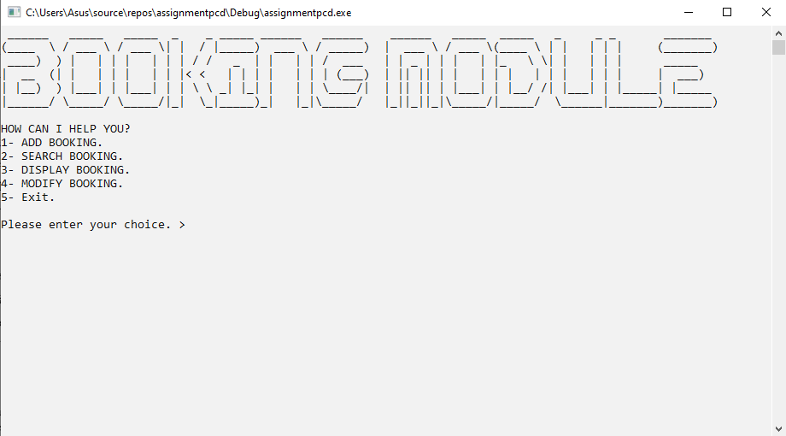

1) Main menu that display 5 function which is add booking function, search booking function, display booking function, modify booking function and lastly exit function.

b)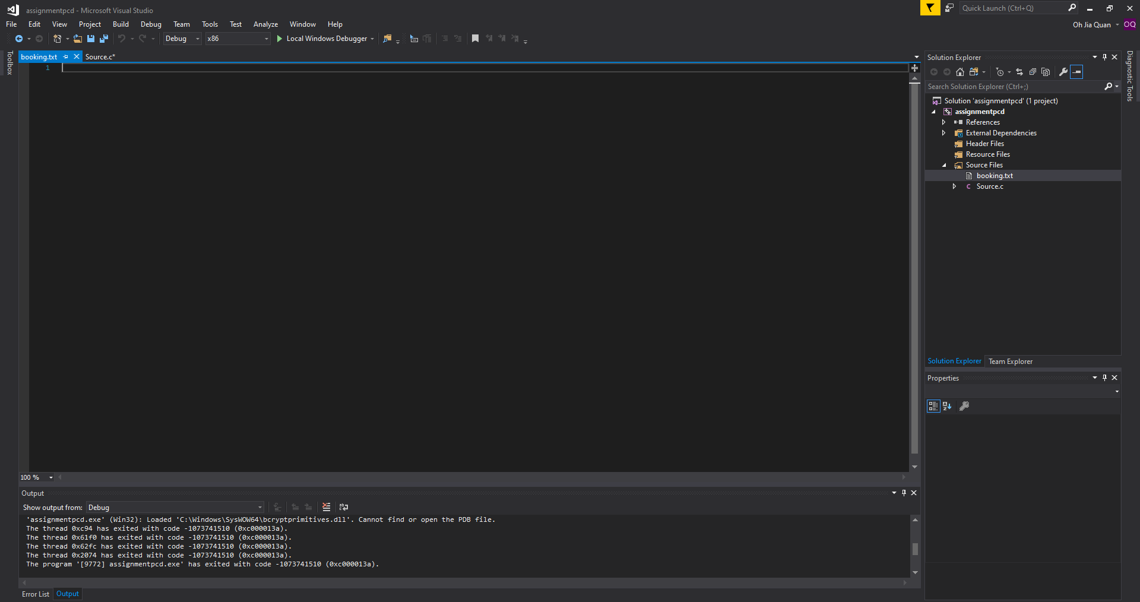

c)

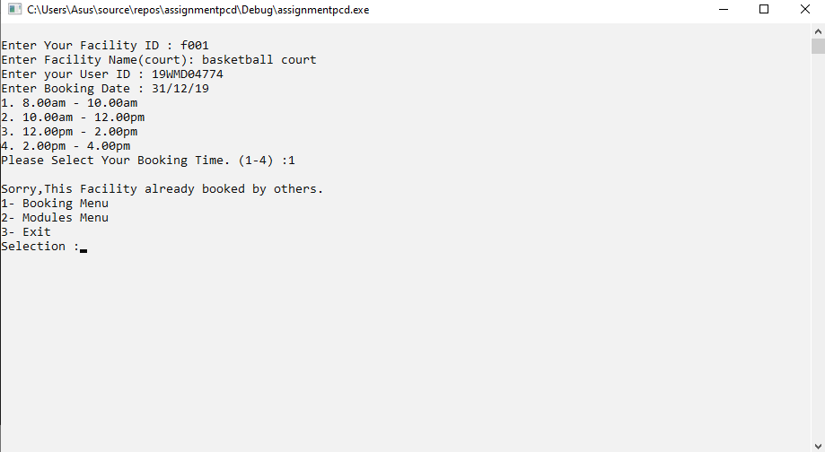

1) Enter facility ID Enter user booking ID  
2) Facility name  
3) Enter user ID  
4) Enter booking date  
5) Select booking time

6) The booking is already confirmed

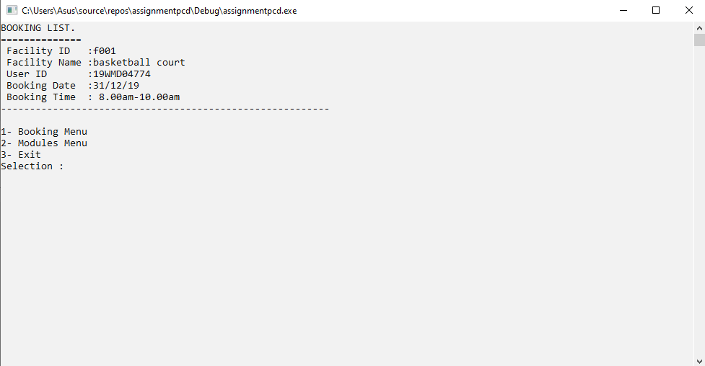

d) 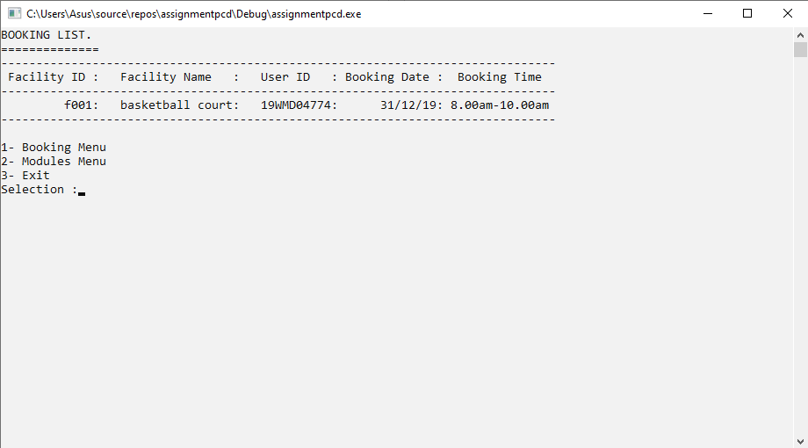

1)This is display booking function.

2) User can back to menu by enter ‘1’ or ‘3’ to exit.

e)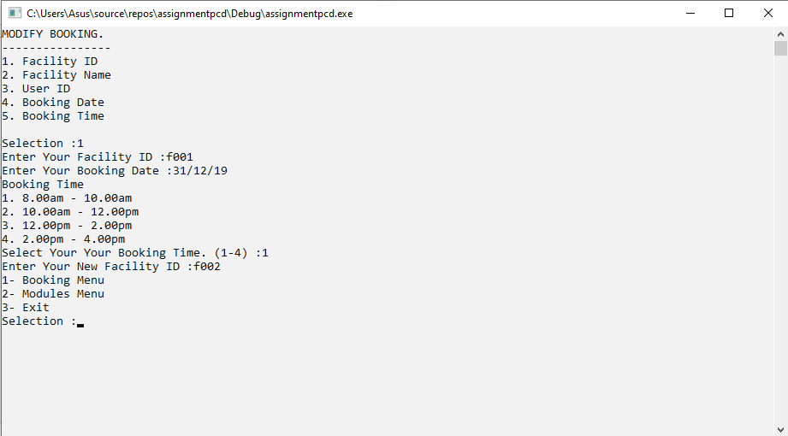

1)This is modify booking function to modify facility ID.

2)User can enter facility ID,booking date and booking time.

3)If match,user can enter new facility ID.

4)User can back to menu by enter ‘1’ or ‘3’ to exit.

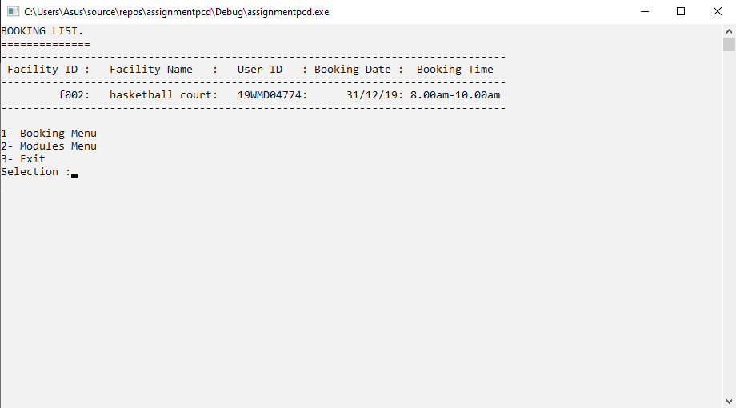

f)

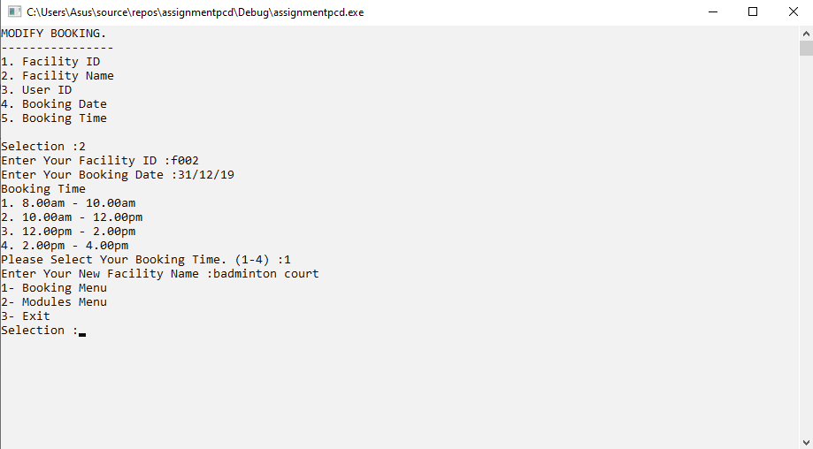

1)This is modify booking function to modify facility name.

2)User can enter facility ID,booking date and booking time.

3)If match,user can enter new facility name.

4)User can back to menu by enter ‘1’ or ‘3’ to exit.

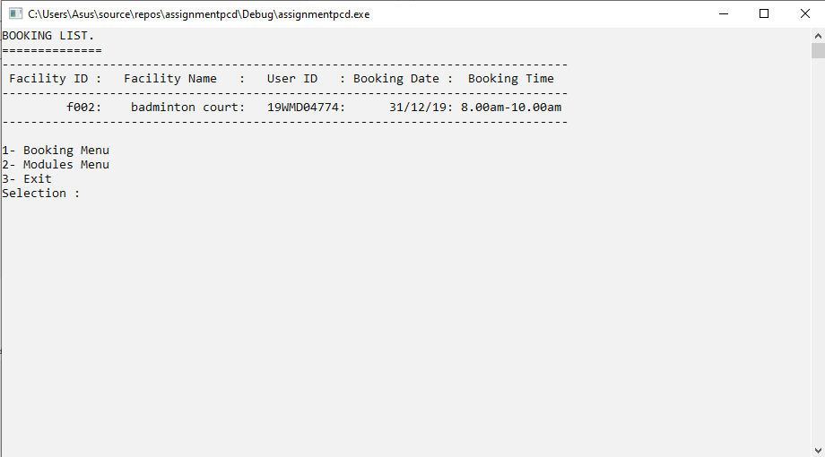

g)

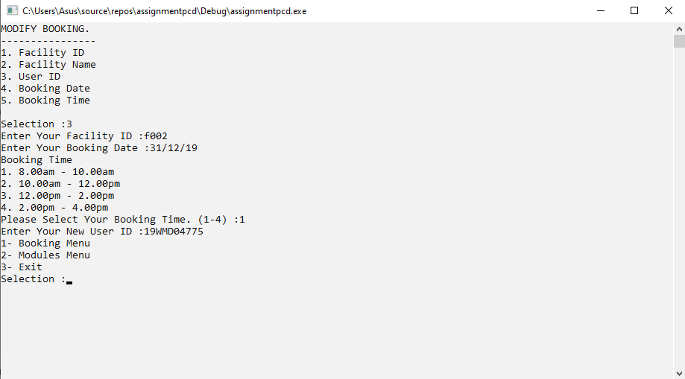

1)This is modify booking function to modify user ID.

2)User can enter facility ID,booking date and booking time.

3)If match,user can enter new user ID.

4)User can back to menu by enter ‘1’ or ‘3’ to exit.

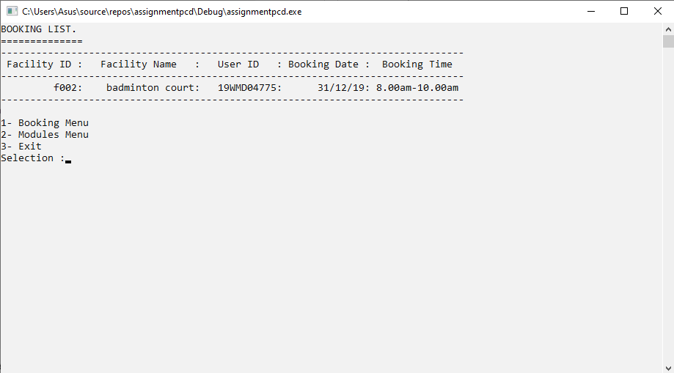

h)

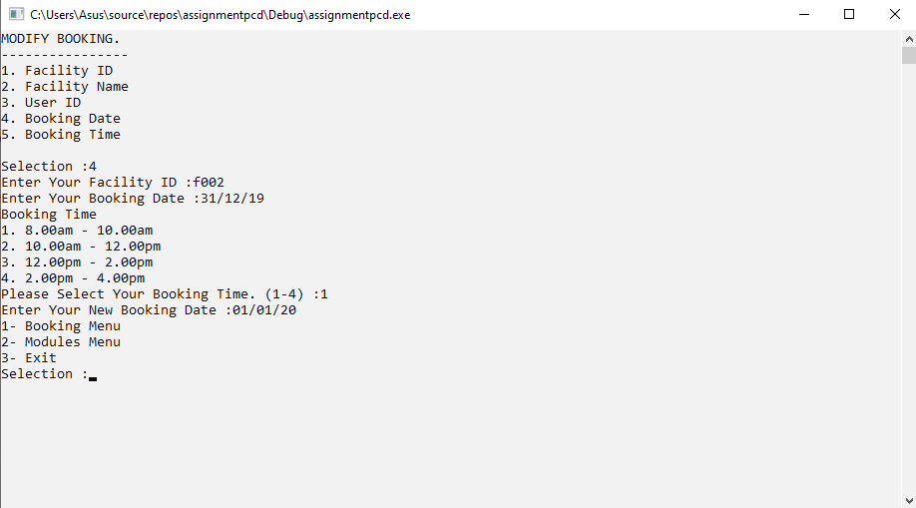

1)This is modify booking function to modify booking date.

2)User can enter facility ID,booking date and booking time.

3)If match,user can enter new booking date.

4)User can back to menu by enter ‘1’ or ‘3’ to exit.

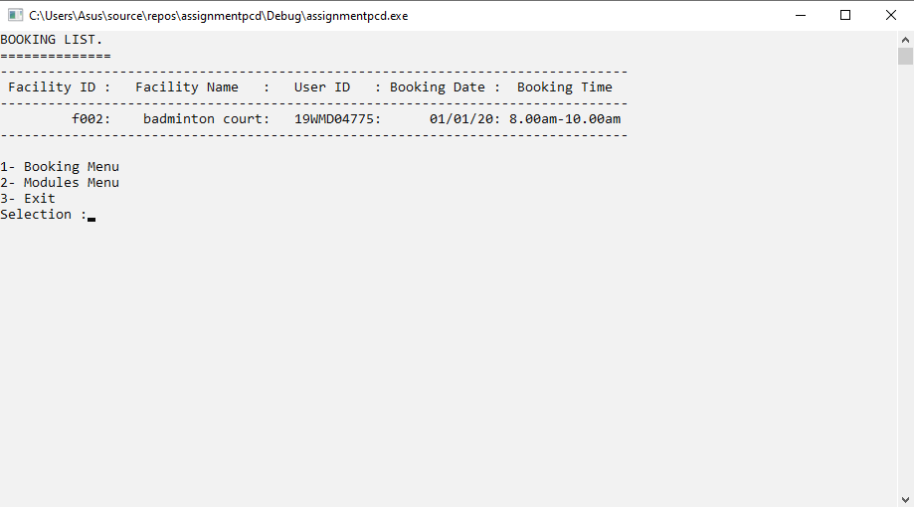

i)

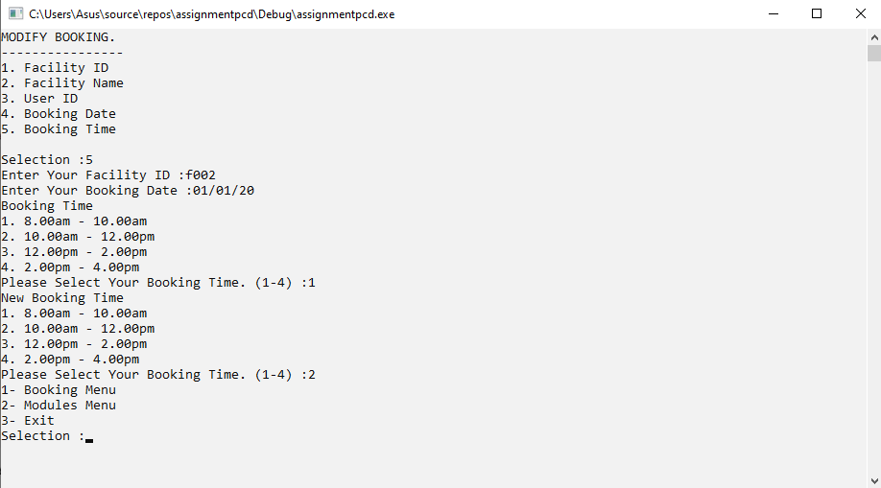

1)This is modify booking function to modify booking time.

2)User can enter facility ID,booking date and booking time.

3)If match,user can choose a new booking time.

4)User can back to menu by enter ‘1’ or ‘3’ to exit.

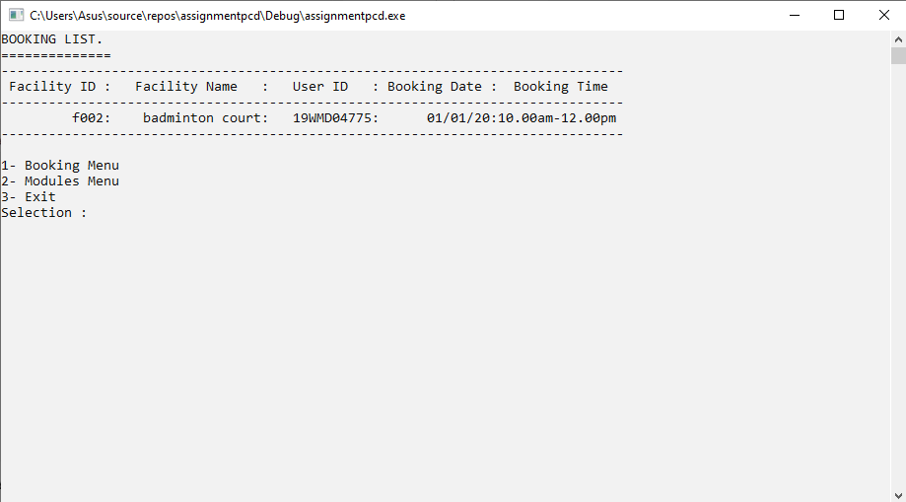

j)

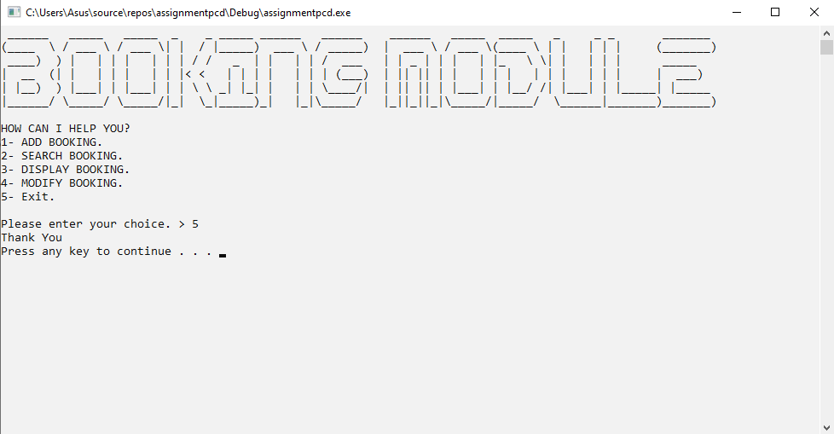

1) Press ‘5’ to exit.